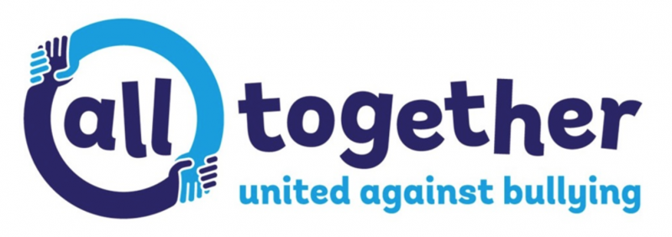
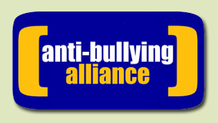

Anti-Bullying at Carnforth

At Carnforth School, our aim is to provide a safe, caring and friendly community environment so that our pupils can learn effectively and maximise their life potential.

We believe that any form of bullying is unacceptable. We understand that it can happen in school and that if it does happen; our school has an ethos of speaking out. The children understand the slogan “Stay safe, Speak out.” As a result, we treat bullying very seriously and all staff and pupils know and understand our anti-bullying policy and procedures.

If a child is being bullied our pupils know that they must tell someone they trust and our staff know that it must be dealt with promptly and effectively.

What is bullying?

The anti-bullying alliance define bullying as, “the repetitive, intentional hurting of one person or group, where the relationship involves an imbalance of power. It can happen face to face or online.”

There are four key elements:
- Hurtful
- Repetition
- Power imbalance
- Intentional

Bullying can be:
Physical – pushing, poking, kicking, hitting, biting, pinching etc.
Verbal - name calling, sarcasm, spreading rumours, threats, teasing, belittling.
Emotional – isolating others, tormenting, hiding books, threatening gestures, ridicule, humiliation, intimidating, excluding, manipulation and coercion.
Sexual – unwanted physical contact, inappropriate touching, abusive comments, homophobic abuse, exposure to inappropriate films etc.
Online /cyber – posting on social media, sharing photos, sending nasty text messages, social exclusion
Indirect - Can include the exploitation of individuals.

https://www.anti-bullyingalliance.org.uk/tools-information/advice-parents

anti-bullying policy link

