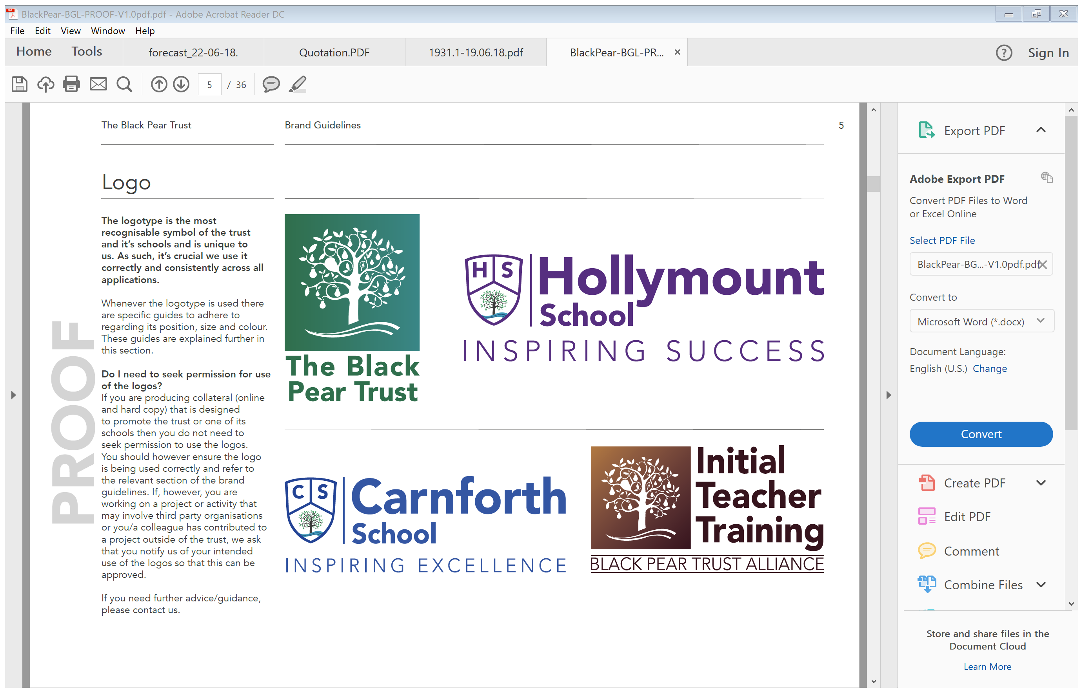

“I want every child to be able to aim for the stars, and to be supported in reaching them.” (David Laws, Education Minister, 2012). Since September 2013 each school has received funding called Sports Premium. The funding is to make ‘additional and sustainable improvements to the provision of PE and sport for the benefits of all pupils to encourage the development of healthy, active lifestyles.’ (Gov) This means that we can use the premium to:

* Develop or add to the PE and sport activities that our school already offers
* Build capacity and capability within the school to ensure that improvements made now will benefit pupils joining the school in future year.

This funding is being jointly provided by the Departments for Education, Health and Culture, Media and Sport, and will see money going directly to primary school Head Teachers to spend on improving the quality of sport and PE for all their children. The sport funding can only be spent on sport and PE provision in schools.

**2023/2024 Sports Premium Strategic Plan - Impact**

|  |  |  |
| --- | --- | --- |
| **Number of children** | **168 (R-6)** | |
| **Allocation for September 2023- July 2024** | **£17,800** | |
| **Total allocation** | **£17,800** | |
| **Current Attainment** | **Target % expected and above** | **Target % exceeding** |
| **End of KS1** | **83%** | **17%** |
| **Current Attainment** | **Target % expected and above** | **Target % exceeding** |
| **End of KS2** | **78%** | **15%** |
| **Pupil Voice** | | |
| **Llanrug Y5&6**  ‘I enjoyed rock climbing, because I have never done it before and it was really fun!’  ‘I liked canoeing on the open water. I have never done that before!’  **Oakwerwood -Y4**  ‘We got to sleep in bunkbeds in little cabins. It was really exciting.’  ‘We got to go ziplining which was really fun. It went on for ages and was really fast!’  **Pupil voice from the Healthy Living Days:**  ‘We loved working in a team and it helped build my team work skills.’  ‘It was nice to be taught by other adults and coaches from different sports clubs.’ | | |
| At Carnforth School we are fully aware of the importance of Sport and PE. We are committed to providing our children with the opportunities to get participate in a variety of different sports and games in a competitive environment, to foster a love of sport that remains with them for life and opens up opportunities beyond what we offer at school. That we provide opportunities to develop healthy, active lifestyles through:   1. the engagement of all pupils in regular physical activity – the Chief Medical Officer guidelines recommend that all children and young people aged 5 to 18 engage in at least 60 minutes of physical activity a day, of which 30 minutes should be in school 2. the profile of PE and sport is raised across the school as a tool for whole-school improvement 3. increased confidence, knowledge and skills of all staff in teaching PE and sport 4. broader experience of a range of sports and activities offered to all pupils 5. increased participation in competitive sport   The DfE vision is that, “all pupils leaving primary school to be physically literate and with the knowledge, skills and motivation necessary to equip them for a healthy, active lifestyle and lifelong participation in physical activity and sport.”  The Primary School Physical Literacy Framework, developed by Youth Sports Trust, Sport England, County Sport Partnership Network, Association of Physical Education and Sports Coach UK describe Physical Literacy as, “the motivation, confidence, physical competence, knowledge and understanding that provides children with the movement foundation for lifelong participation in physical activity. Enabling them to be physically literate supports their development as competent, confident and healthy movers.”  **The improvements in school will provide additional, sustainable improvements to the provision of PE and sport for all pupils and to encourage healthy, active lifestyles as:**   * Staff members will have increased their knowledge, skills and confidence teaching Physical Education * Pupils will be educated about the positives of a healthy active lifestyle * Pupil will be provided with a broader experience of sports | | |

|  |  |  |  |  |  |  |  |  |  |  |  |
| --- | --- | --- | --- | --- | --- | --- | --- | --- | --- | --- | --- |
| 1. the engagement of all pupils in regular physical activity – kick-starting healthy active lifestyles | | | | | | | | | | | |
| At Carnforth School we feel having a healthy active lifestyle is key to having positive mental health and as a result encouraging children to take up daily exercise and healthy eating is paramount. This viewpoint is supported by the Mental Health organisation who have produced a report that supports this. They believe that:  Physical activity has a huge potential to enhance our wellbeing. Even a short burst of 10 minutes’ brisk walking increases our mental alertness, energy and positive mood.  Participation in regular physical activity can increase our self-esteem and can reduce stress and anxiety. It also plays a role in preventing the development of mental health problemsand in improving the quality of life of people experiencing mental health problems.  **Impact on our mood**  Physical activity has been shown to have a positive impact on our mood. A study that asked people to rate their mood immediately after periods of physical activity (e.g. going for a walk or doing housework), and periods of inactivity (e.g. reading a book or watching television) found that the participants felt more content, more awake and calmer after being physically active compared to after periods of inactivity. They also found that the effect of physical activity on mood was greatest when mood was initially low. There are many studies looking at physical activity at different levels of intensity and its impact on people’s mood. Overall, research has found that low-intensity aerobic exercise – for 30–35 minutes, 3–5 days a week, for 10–12 weeks – was best at increasing positive moods (e.g. enthusiasm, alertness).  **Impact on our stress**  When events occur that make us feel threatened or that upset our balance in some way, our body’s defences cut in and create a stress response, which may make us feel a variety of uncomfortable physical symptoms and make us behave differently, and we may also experience emotions more intensely. The most common physical signs of stress include sleeping problems, sweating, and loss of appetite.Symptoms like these are triggered by a rush of stress hormones in our body – otherwise known as the ‘fight or flight’ response. It is these hormones, adrenaline and noradrenaline, which raise our blood pressure, increase our heart rate and increase the rate at which we perspire, preparing our body for an emergency response. They can also reduce blood flow to our skin and can reduce our stomach activity, while cortisol, another stress hormone, releases fat and sugar into the system to boost our energy. Physical exercise can be very effective in relieving stress. Research has found that highly active individuals tend to have lower stress rates compared to individuals who are less active.  **Impact on our self-esteem**  Exercise not only has a positive impact on our physical health, but it can also increase our self-esteem. Self-esteem is how we feel about ourselves and how we perceive our self-worth. It is a key indicator of our mental wellbeing and our ability to cope with life stressors. Physical activity has been shown to have a positive influence on our self-esteem and self-worth. This relationship has been found in children, adolescents, young adults, adults and older people, and across both males and females.  **Dementia and cognitive decline in older people**  Improvements in healthcare have led to an increasing life expectancy and a growing population of people over 65 years.Alongside this increase in life expectancy, there has been an increase in the number of people living with dementia and in people with cognitive decline.  The main symptom of dementia is memory loss; it is a progressive disease that results in people becoming more impaired over time.Decline in cognitive functions, such as attention and concentration, also occurs in older people, including those who do not develop dementia. Physical activity has been identified as a protective factor in studies that examined risk factors for dementia. For people who have already developed the disease, physical activity can help to delay further decline in functioning.Studies show that there is approximately a 20% to 30% lower risk of depression and dementia for adults participating in daily physical activity.Physical activity also seems to reduce the likelihood of experiencing cognitive decline in people who do not have dementia.  **Impact on depression and anxiety**  Physical activity can be an alternative treatment for depression. It can be used as a standalone treatment or in combination with medication and/or psychological therapy. It has few side effects and does not have the stigma that some people perceive to be attached to taking antidepressants or attending psychotherapy and counselling. Physical activity can reduce levels of anxiety in people with mild symptomsand may also be helpful for treating clinical anxiety.Physical activity is available to all, has few costs attached, and is an empowering approach that can support self-management.  For more details about how physical activity can help increase wellbeing and prevent or manage mental health problems, read the [full report](https://www.mentalhealth.org.uk/content/assets/PDF/publications/let's-get-physical-booklet.pdf?view=Standard), or get more information about how exercise can improve your mental health on the website: [www.mentalhealth.org.uk](https://www.mentalhealth.org.uk/). | | | | | | | | | | | |
| Sport | | Year Group | | Objective | | Implementation | Cost | Lead | Resources | Monitoring | |
| **The Daily Mile (exercise)** | | Y1-6 | | To re-establish Daily Mile structure and challenges to ensure that all pupils participate in daily sporting activity | | Audit staff and pupil voice of the daily mile  To relaunch certificates and rewards.  To structure daily mile sessions to more closely match to all pupils needs. | £2353.37 | Class teacher and PE Lead | Record sheet  Staffing | Data analysis  Pupil Voice  Staff voice | |
| **Lunchtime play provision - Opal schools** | | YR to Year 6 | | To develop children’s gross motor skills through structured play sessions.  To develop children’s  Understanding of sustained play through targeted adult provision focusing on high quality interactions to move learning on.  To further develop children’s emotional resilience through play. | | To audit current play based provision.  To liaise with Opal play leaders.  To provide staff training on play based provision interactions. | £4001.70 | PE Lead  Deputy Head  Opal play leads | Opal audits,  Resource lists,  Equipment lists,  Risk assessments  CPD | Observations of children  Child/ adult voice  Records of achievement | |
| **Training and development of play workers** | | All pupils | | To ensure all pupils have access to high quality play based provision.  Provide children with a high quality play based education  To broaden the sporting opportunity available to pupils | | BC to support with equipment audits and identify where additional provision is needed.  To act upon the advice and recommendations of Opal leaders.  Child questionnaires to be completed about equipment – and what equipment would be needed.  To identify the need for key areas of play development.  To provide training to staff on the implicit play behaviours and interactions to further the quality of provision. | £5003.71 | PE Lead  Deputy Head  Opal play leads | Opal audits,  Resource lists,  Equipment lists,  Risk assessments  CPD | Observations of children  Child/ adult voice  Records of achievement | |
| At Carnforth School all pupils have the opportunity to participate in dance and gymnastic sessions led by coaches alongside their class teacher. The use of coaches within sports is a useful attribute within the school as it provides a clear focus to each lesson as the coaching is sports specific. The teacher works alongside the coach and is supported, rather than replaced or displaced. The teacher is able to develop their own skills as well as their confidence and competence within a particular area. The benefits can also be reciprocal as the coach is able to learn skills from the class teacher such as promoting positive behaviours, large group organisation and ensuring a safe environment. At Carnforth School the children enjoy having a range of coaches in school. Studies have shown that sports coaches can be very beneficial role models and bring many benefits to schools.  According to Wesport the benefits of using coaches in schools are that they:  Provide additional capacity to help schools deliver a greater range of sports opportunities for children.  Work alongside teachers to improve their knowledge around the development of core skills in young people such as locomotion, object control, stability, balance and co-ordination.  Support teachers to develop FUNdamental movement skills in young people to help them to be more confident to participate in sport and physical activity as part of a healthy and active lifestyle.  Promote lifelong participation in sport and physical activity to young people.  Be role models and play a pivotal role in the mentoring and development of young leaders as coaches  Contribute to the raising achievement agenda in schools through developing confidence and self-esteem in young people through sport and through educating young people on the importance and value of sport.  Support the transition between school and community sport through helping to create and develop links with local community sports clubs. | | | | | | | | | | | |
| Sport | Year Group | | Objective | | Implementation | | | Cost | Lead | Resources | Monitoring |
| **Swimming** | Y 1 - 6 | | To increase the number of children achieving the 3 national curriculum requirements for water safety at the end of KS2 | | To provide additional top-up swimming lessons to meet the 3 national curriculum requirements. | | | £1000 | Sports Lead | Pool Hire  Instructor  Travel  Staffing | Data analysis |
| **Coaching/sports lead** | Y1-6 | | To develop levels of fitness  To broaden sporting opportunity available to pupils  To increase engagement in a wider range of sports | | Collect viewpoints of children and parents for future clubs.  Set up clubs that include sports for children.  To provide wider opportunities to participate in sporting activities beyond those which are offered as part of nation curriculum requirements. | | | £2353.37 | Sports Lead | Staff | Staff Voice  Planning trawl  Data |
| **4. Broader experience of a range of sports and activities offered to all pupils**  **5. Increase participation in competitive sports** | | | | | | | | | | | |
| At Carnforth School we endeavour to enhance our pupils experience of sport by offering a range of opportunities to participate in both adventure and sporting activities because we feel it is key to our pupils academic achievement and wellbeing. According to Sport England physical activity can reduce stress and anxiety, with the mastering of new skills often increasing confidence and self-esteem. That there is much evidence that physical activity contributes to enjoyment and happiness, and more broadly to life satisfaction, with the element of social interaction often cited as central to this. Also volunteers and sports fans also experience increased life satisfaction, associated with having a sense of purpose and pride. That self-esteem and confidence are known to increase through short or long term participation or volunteering, because of the opportunity to develop new skills and relationships. That there is general agreement that sport and physical activity has the potential to reduce anxiety and depression symptoms, with most evidence on this focusing on specific subgroups. Other positive outcomes include improved cognitive functioning, benefits for people with dementia, and impacts around emotion regulation. | | | | | | | | | | | |
| Sport | Year Group | | Outcome | | Implementation | | | Cost | Lead | Resources | Monitoring |
| **Festival and events** | Year 1-6 | | To develop team work skills  To promote a competitive ethos  To experience competition against other schools | | To provide children with a range of sporting activities to develop their teamwork skills and broaden opportunities.   * Sports Day * Volley ball competition * Tag rugby competition * Handball competition * Hockey competition * Netball competition * Football competition | | | £500 | Class teacher  PE Lead  Travel  Equipment | Minibus | Competition Results  Pupil voice |
| **Healthy Living Days** | Y1 - 6 | | To experience new sports and understand the importance of healthy living | | Source new sports for children to experience. Plan healthy living days for the children to experience new sports and understand the importance of healthy living for the mind and body. | | | £1500 | PE Lead External agencies | Equipment External companies | Pupil voice |
| **Residential** | Y4 & 5 | | To experience new sports.  To build resilience when taking part in challenging activities.  To develop teamwork skills. | | Attend a residential outdoor centre.  Experience adventurous activities.  Work together to solve problems to complete activities. | | | £1125 | Assistance to costs | Centre costs  Equipment | Pupil Voice |