

Supporting Families Offer 2025-26
At Carnforth School we recognise the challenges that families face in bringing up children and there may be times when you need extra help and support. If you do need extra support please come and talk to us, there are many ways in which we can help as outlined in this offer of early help.

The diagram below shows the range of needs at different levels. We use this graduated approach to make sure we provide the best support for different families’ individual situations:
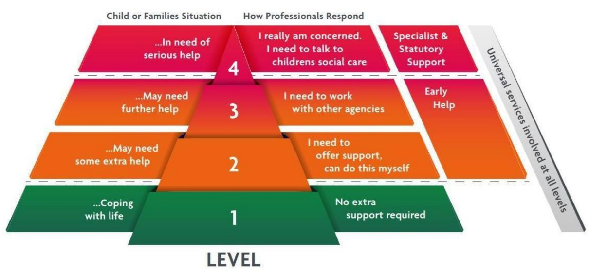

Providing early help to our pupils and families at Carnforth School means we are more effective in promoting support as soon as we can. Early help means providing support as soon as a problem emerges, at any point in a child’s life, beginning with the foundation stage. We have a safeguarding culture that promotes trust between all adults and children so that all children have a trusted adult that they can speak to about any of their worries or concerns. At Carnforth School, we believe that safeguarding is everyone’s responsibility and promote this accountability with all staff.

At Carnforth School, we believe that safeguarding is everyone’s responsibility and promote this accountability with all staff. In school we have a safeguarding team that staff can liaise with and take overall responsibility and they are:
Keren Finnegan    DSL | Paul Prigg  DSL and Head teacher   | Vicky Smith    DDSL and SENDCO | Jemma Newton Smith  DDSL  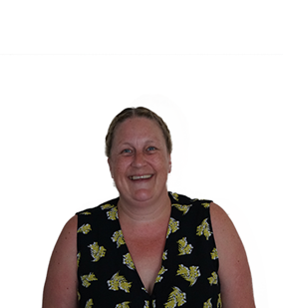 | Megan Smith  DDSL  
kfinnegan@blackpeartrust.org | pprigg@carnforthschool.org | vsmith@carnforthschool.org | jnewton-smith@carnforthschool.org | msmith@carnforthschool.org

The nominated safeguarding governor is: Email: PEdwards@blackpeartrust.org
The Chair of Governors: Mrs Gill Ellis Email: Gellis@blackpeartrust.org

Early Help Pathway Early Help is a pathway to supporting you and your child as they grow up when you or they may need further support or guidance. Providing early help to our pupils and families at Carnforth School means we can improve outcomes for children, families, and communities, providing support as soon as a problem emerges, at any point in a child’s life, from the early years through to teenage years.
Early help relies upon local groups and people in the community, sometimes we work together to help children, young people, and their families. Everyone needs help at some time in their lives and therefore an ethos of early help is important for any school.


Early Help can support children and their families who may be struggling with:
- Routines and family rules
- Families who may be not be eating healthy food or who are trying to keep to a healthy lifestyle
- Children who are caring for a family member
- Children who may not want to go to school for different reasons
- Disability within the family, including children being a young carer
- Children in the family have special educational needs (SEND)
- Children who may becoming involved in anti-social or criminal behaviour
- Children who go missing from home
- Children or parents / carers misusing drugs or alcohol
- Children at risk of being tricked, forced, or made to work in the criminal world
- Children who may need support because they may live in a home and see drug or alcohol abuse or adult mental health problems.
- Children who have parents who argue a lot (and sometimes might hurt each other) whether the parents live together or apart.
- Children at risk of being groomed to join groups which support illegal views
- A privately fostered child (a child from another family living within your family home)

What is an Early help Assessment?
It is a tool we use to support our work with families and helps us to identify what families need help with and inform how we can work with families to make the changes they need.
We work with families using the ‘Circle of Support’. It helps to guide our conversations and find out what is working well, and what additional support may benefit your family.
We focus on all those living in your family home and wider family connections to develop a clear picture of what day to day life is like. The Circle of Support has a set of question prompts for parents and carers, and another set of questions that are specifically for children and young people. These tools help us to get the views of everyone in your family.
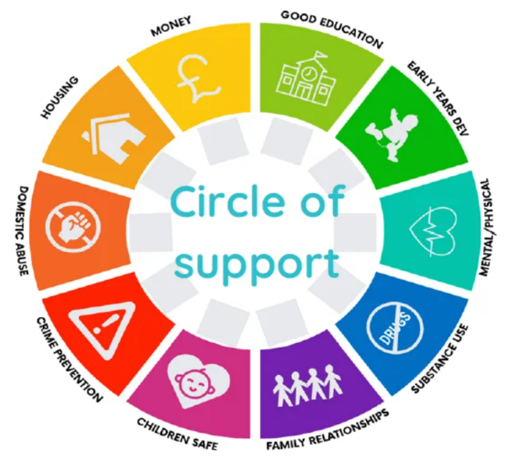
Within the Circle of Support is the Readiness to Change model, and the family will be asked to score themselves on each area of the assessment criteria.
The early help assessment isn't a referral form for other professionals to complete in order to receive another service to support the family. The purpose of the assessment is to identify the help that's needed, and to inform a family plan of support which will identify who may be able to best support you.
The assessment can be shared with other services, who can offer additional support. It helps everyone to work together, to make sure you get the right help at the right time, and to strengthen community connections. It's a shared document so that you only tell your story once. This document is stored safely in our case management system.
When we use a restorative approach in the assessment, we focus on asking key questions to understand why there are challenges or concerns. The idea is to uncover the root causes, address any harm, and improve things for children, young people and families. These questions are open-ended and don't blame anyone.
The goal is to work together to find solutions.

The early help assessment process - step by step

- When completing an assessment, we'll work with family members to build relationships and involve them in every part of the process.
- We'll work with each child to understand what's important to them and place them at the centre of the assessment.
- We'll use different activities to help gather information, and with families’ agreement we'll speak with other professionals who have more information that's important to include. This could include school, nursery, or health visitors.
- We'll talk about family history as this informs us of each child’s life experience, and include strengths and achievements.
- We'll focus on all members of the family and how their lives are, or have the possibility of, impacting on other household members.
- We may use other types of assessment tools, such as an exploitation risk assessment, if we're worried about the safety of a family member.
- We'll include any other assessment that has already been completed, such as the information contained in an education, health and care plan, or information collected in reports from an education, health and care needs assessment, to avoid duplication.
- We'll always include factual information in the assessment, and where professional judgement or opinion is included this will be clearly noted.
- Assessments will be clear, informative, and not overly descriptive to ensure that we can identify what each part means for the child/ren.
- We'll use the assessment to inform a family plan which everyone will work towards, and where continued or more help is needed we may need to revisit the assessment.

Early help relies upon local groups and people in the community, sometimes we work together to help children, young people, and their families. Everyone needs help at some time in their lives and therefore an ethos of early help is important for any school.
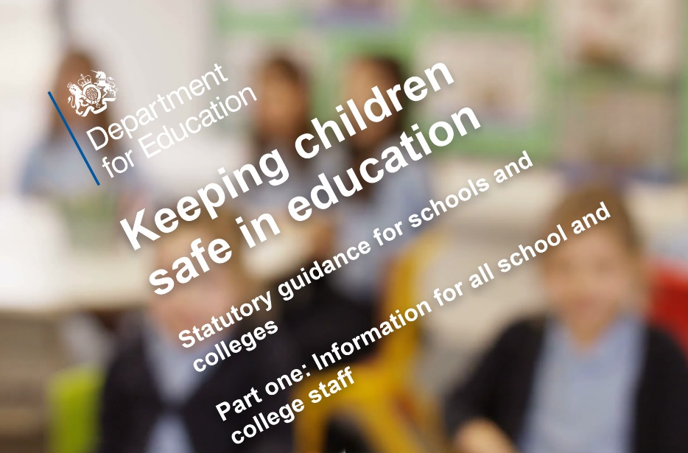
In Keeping Children Safe in Education 2024 it makes it clear that ALL staff should be aware of their local early help process and understand their role in it. In addition, this statutory document makes it clear that any child may benefit from early help, but all school and college staff should be particularly alert to the potential need for early help for a child who:
➢ Is disabled and has specific additional needs
➢ Has special educational needs (whether or not they have a statutory education, health care plan) Is a young carer
➢ Is showing signs of being drawn in to anti-social or criminal behaviour
➢ including gang involvement and association with organised crime groups
➢ Is frequently missing/goes missing from care or from home
➢ Is at risk of modern slavery, trafficking or exploitation
➢ Is a risk of being radicalised or exploited
➢ Is in a family circumstance presenting challenges for the child, such as drug and alcohol misuse, adult mental health issues and domestic abuse
➢ Is misusing drugs or alcohol themselves
➢ Has returned home to their family from care; and is a privately fostered child.
➢ Is persistently absent from education, including persistent absences for part of the school day
➢ At risk of honour-based abuse - for example: FGM
All Carnforth School, staff are aware of the offer of early help and at all times staff consider if there is any offer of early help that we can make in order to help a child thrive. We believe that early interventions for children or families, in many cases, will prevent children from experiencing harm. Within school we provide the following early help support for all children, striving to ensure concerns, no matter how small they may seem, are listened to and supported quickly and effectively therefore maximising the chance of safeguarding all of our children.
Emma McGorman is in school one day a week to work with identified children needing support. This personalised programme is delivered to meet the needs of the child and continues until significant progress has been made or other resources have been accessed to provide support where appropriate.

This is led by Mrs Keren Finnegan who works closely with the SENCo, DSL’s, school family support worker, PSER support worker and external agencies.

Dr Aimee Sweet is in school five times per term and she works one to one with children, carries out observations and provides reports to identify and assess difficulties children may be having with learning. She offers recommendations and support
Play Therapy
Every child’s attendance is important to us and as a result is monitored carefully. If a child’s attendance decreases to below 95% and 93% then letters are sent to the parent/carers to raise awareness of it and the impact on the education of the child. If a child’s attendance decreases below 90% then formal attendance meetings are carried out to identify any barriers and support (walking bus, attendance support plans, family support worker referral, education welfare officer involved) required to improve their attendance.
We also provide an attendance minibus to collect identified pupils and get them to school on time.
Pastoral Team
Educational Psychologist


Attendance
We work closely with this professional body as they provide support, advice, consultation and training with school and the parent/carers. This service sits within Worcestershire CAMHs (Child and Adolescent Mental Health Services). They work with children experiencing risk of mental health difficulties.
CAMHS CAST

Behaviour Support Team
Senior Mental Health Worker
This is an outreach service: Mrs W Allen is our schools link worker and she works with identified children on a one to one basis, carries out observations and writes reports to provide information to school to support children with social and emotional difficulties.
We work closely with the team who provide support with identified children who show social and emotional difficulties. They carry out observations and provide advice
Peter Cox is the trained Senior Mental Health Lead in school and has gained the relevant qualifications in order to support school staff and children to develop positive mental health and wellbeing. The Senior Mental Health Lead’s role is to provide training to staff to spot signs and symptoms of common mental health issues, provide support and reassurance, and guide the child or adult to seek professional support they may need.
Within school we provide the following training to staff and early help support for all children, striving to ensure concerns, no matter how small they may seem, are listened to and supported quickly and effectively therefore maximising the chance of safeguarding all of our children
Our school delivers Personal Social, Health and Economics (PSHE) and Relationships and Sex Education (RSE) programmes as well as British Citizenship to further support the children’s understanding of how to keep themselves safe
Is a service which provides advice and support for families who have a child with special educational needs/disability (SEND). SENDIASS Worcestershire and Herefordshire (hwsendiass.co.uk)
The Carnforth School Information Report (SIR) provides information about how the school supports children with SEND. https://www.carnforthschool.org/key-information/send-offer

As part of Worcester Children First adult learning, 3 different courses are delivered in school for a period of ten weeks over the year to target specific skills and promote family engagement (e.g. cooking, English and Maths)
PSHE
And British Citizenship
Every child is taught how to keep themselves safe online through the curriculum and is further highlighted as we participate in the national e-safety week. Our E-safety lead Mr Davies provides parent workshops through the NSPCC and information on the school website and newsletters to support parents on how to protect their children online

SENDIASS
Online Safety

Family
Learning

Operation Encompass is a police and education early information safeguarding partnership enabling schools to offer immediate support to children experiencing domestic abuse
We work with service to provide support to young carers. This charity is commissioned by Worcestershire County Council to provide assessment, signposting, one to one support and monthly youth clubs for young people with a caring role at home, aged between seven and 17, who live in Worcestershire

Operation Encompass
Worcestershire Young Carers

and other services and providers
All staff have been trained through online training and the DSL has received WRAP training. All staff can identify the early stages of radicalisation and what to do. A PREVENT risk assessment is in place that all staff are aware of it
Prevent trained staff
All staff have received training on FGM. Teachers know how to identify if a child may be at risk. They are aware of the countries and places within this country where children may be taken to for this to happen. They know the signs to look for and most importantly how to refer, following the school’s safeguarding procedures.
Female Genital Mutilation
All staff at Carnforth Primary School have been trained to identify early indicators of potential cases of child sexual exploitation through annual safeguarding training and online courses
Child Sexual Exploitation

