Local Services

Please see below more information on support that is available. Click on each icon to take you to the appropriate web page and most up-to-date information:
The Front Door to  Children’s Services   | If a member of staff, parent/carer or member of the public thinks a child or young person is at immediate risk of significant harm they should contact the Family Front Door (FFD) – 01905 822 666 or in an emergency always call 999.  Do not wait to discuss this with the DSL/DDSL but do report it afterwards.
WSCB (Worcestershire Safeguarding Children’s Board) website.  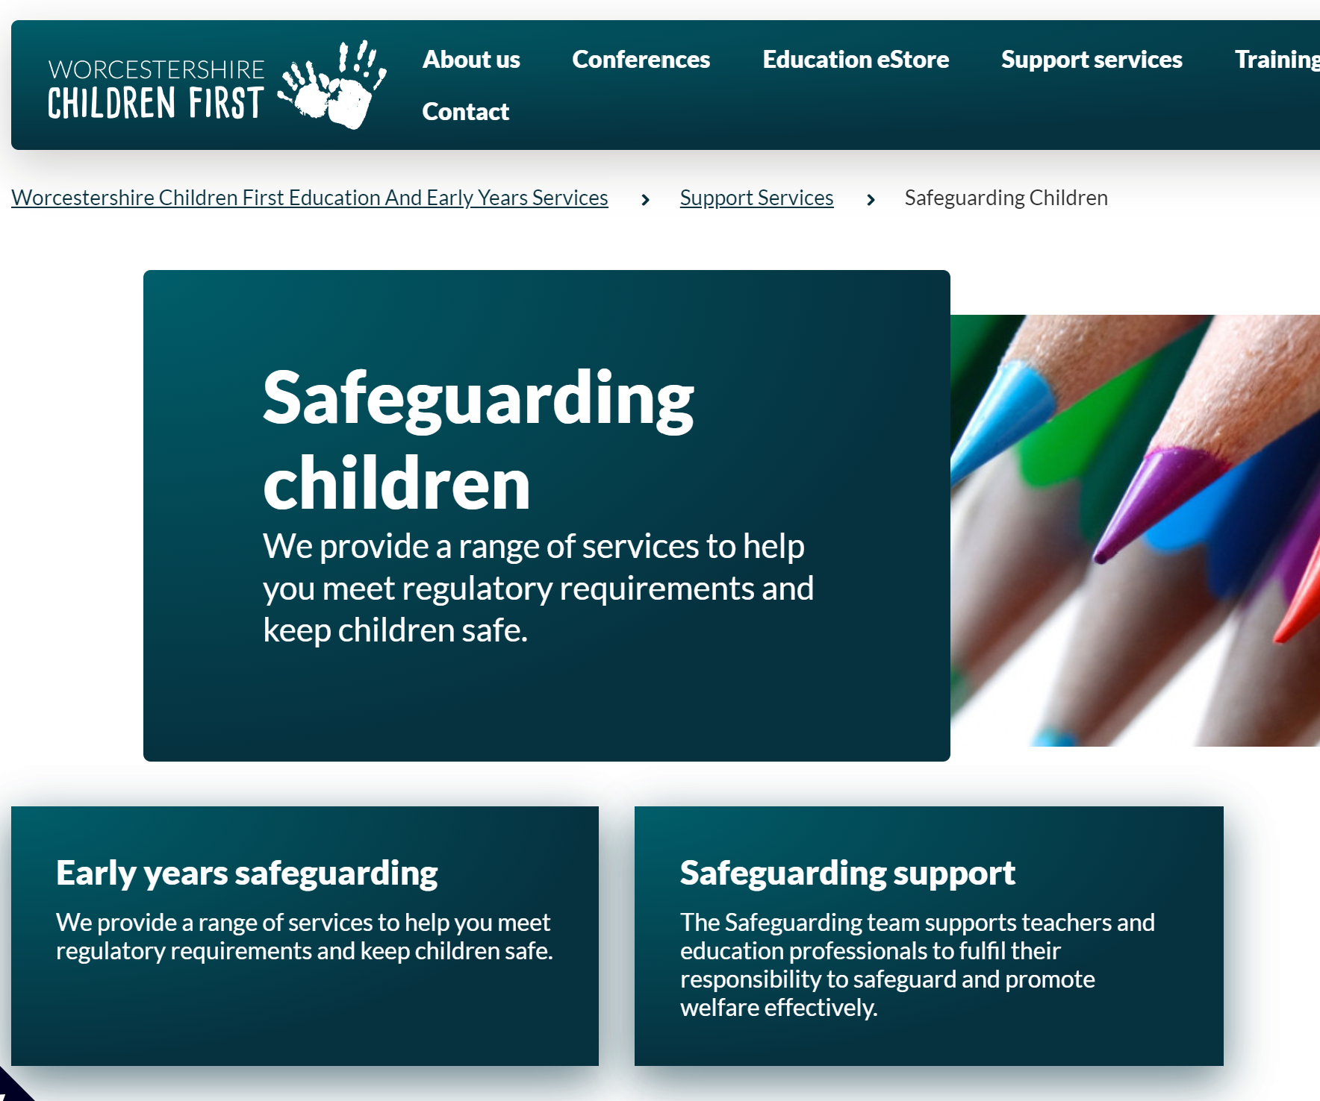 | Important information for parents and professionals across Worcestershire in relation to keeping children safe and avenues of support including early help options. Everyone should know how to access this website which has all the agreed Worcestershire safeguarding and child protection processes on it.
Universal source of help for all families in Worcestershire: Worcestershire Family Information Service (FIS)  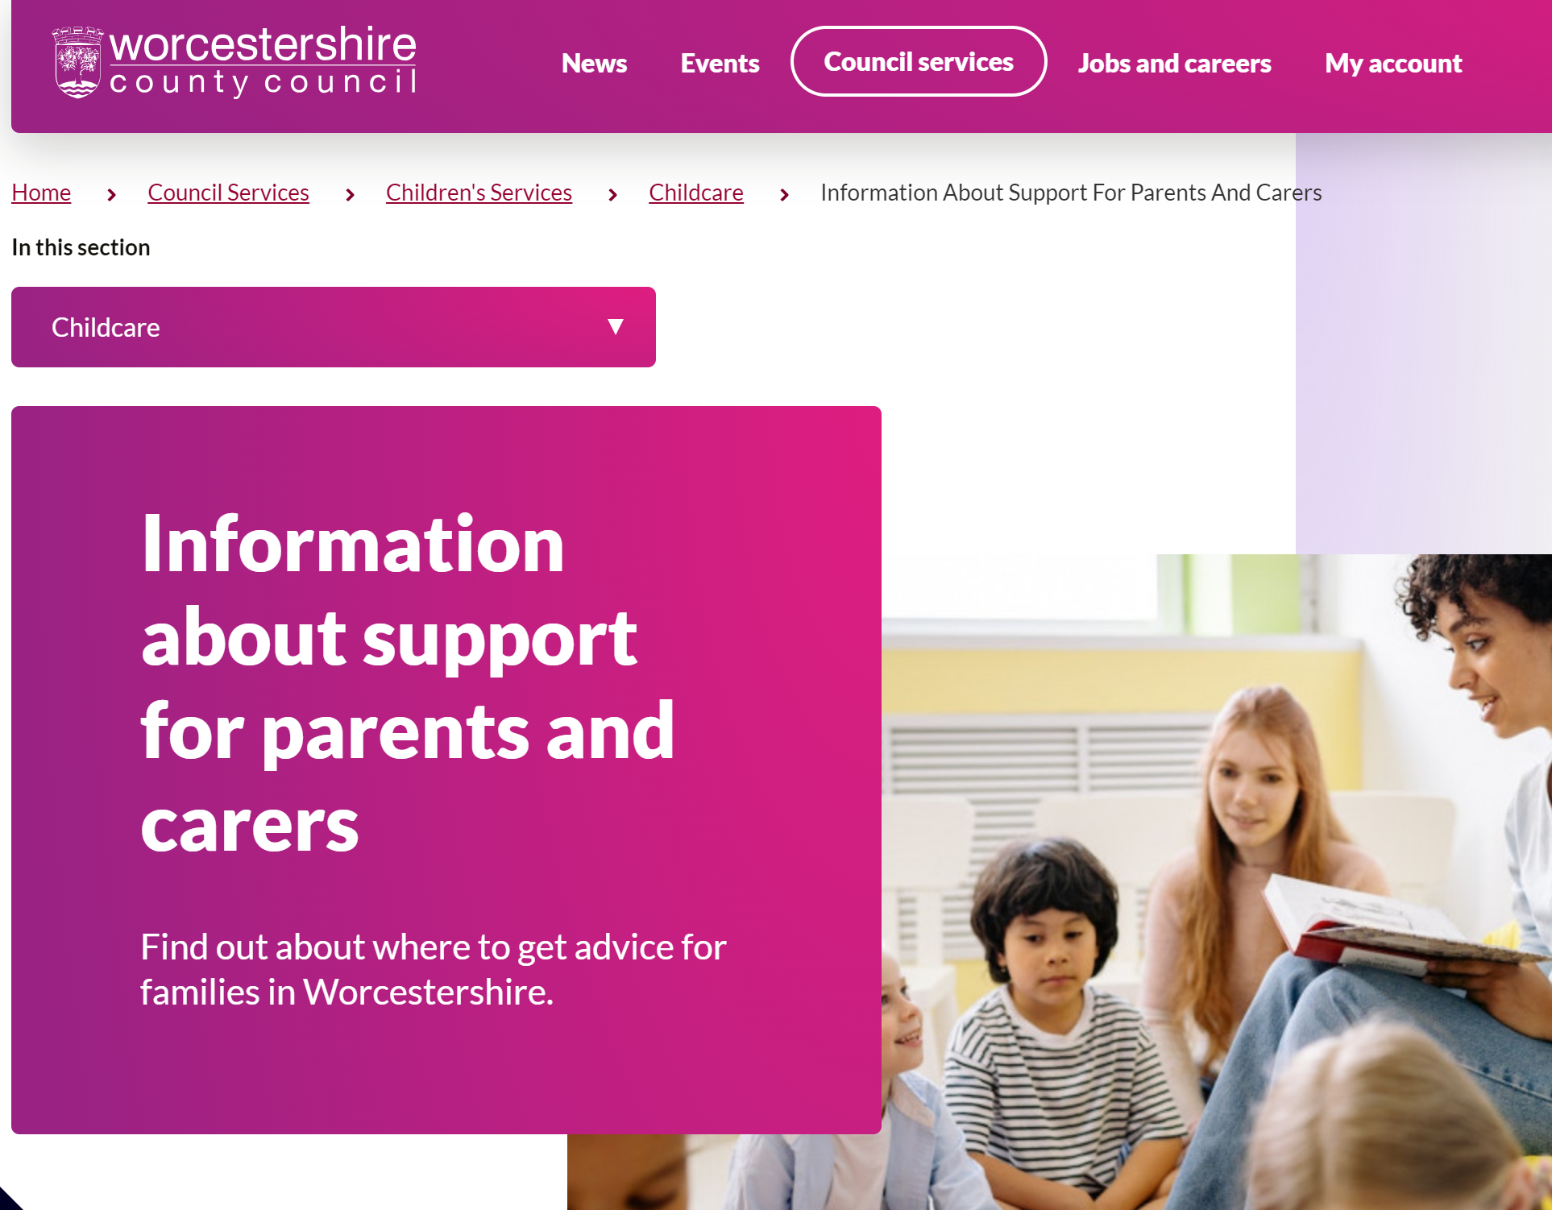 | Worcestershire Family Information Service (FIS)  advisors give impartial information on childcare, finances, parenting and education. FIS are a useful source of information for parents and professionals. They support families, children and young people aged 0-19 years of age (25 for young people with additional needs) and professionals working with these families. They can help link parents up with other organisations that might be able to help or provide the information themselves.
The Trussel Trust  Foodbank in Worcester  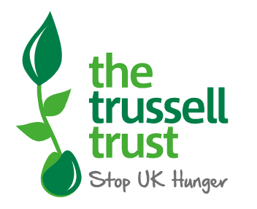  01905 780400  info@worcester.foodbank.org.uk | A record number of people are unable to afford the essentials. Food banks are doing everything they can to help people in their communities.

Home-school support  Worcestershire Home Education Network   | Home education is becoming an increasingly popular option for families in Worcestershire and we have a growing community that are able to offer each other support. Between us we have years of experience in educating children of all ages and are able to organise and put on a range of activities.  Contact us on:  info@worcestershire-home-educators.co.uk
Worcestershire’s Local Offer (SEND)  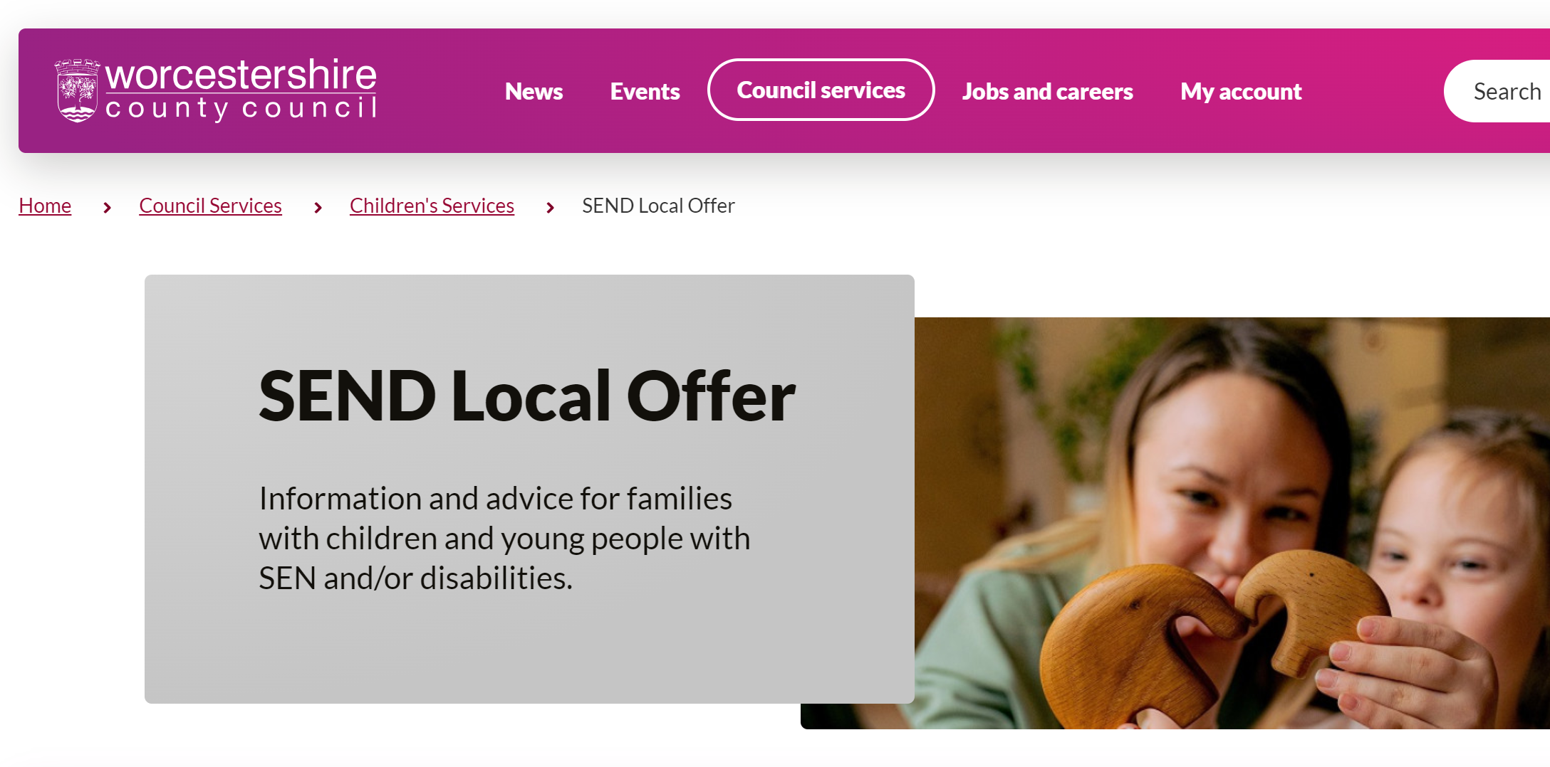 | Information and advice for children and young adults with disabilities and learning needs  Our Local Offer provides information about provision families can expect to be available across education, health and social care for children and young people who have Special Educational Need (SEN) or are disabled, including those who do not have Education, Health and Care (EHC) plans.  You can find out about resources, services, support, activities and events here.
The Family Hub  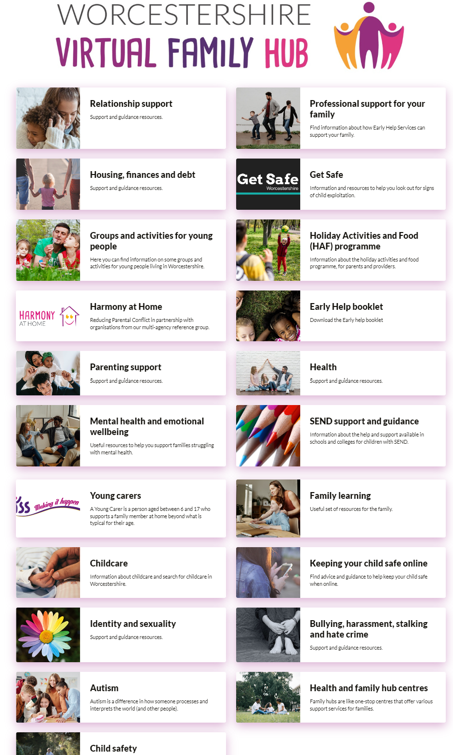 | It is important that families know where to go and get help.  We know that where to start or what to ask for can sometimes be a challenge. We have developed this page to give you a range of different types of resources that are available to you online, on the phone or face to face that you can access directly.  Information and support includes:  - Parenting support  - Health and wellbeing  - SEND Local Offer  - Housing and finances  - Relationships  - Early Help Family support  - GET SAFE
E-safety (Online Safety)  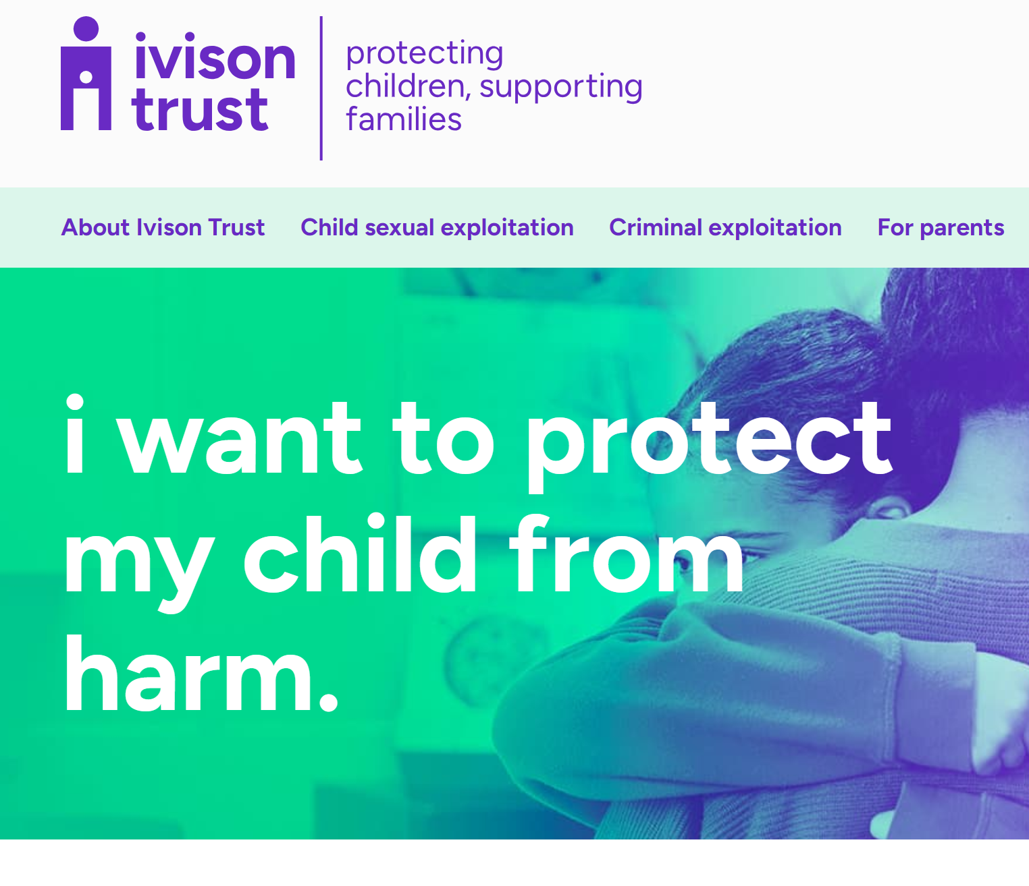 | Online Activity (phones, computers) can be a serious risk to children: The use of technology has become a significant component of many safeguarding issues. Child sexual exploitation; radicalisation; sexual predation, bullying – technology often provides the platform that facilitates harm. With the right support, education and safety measures in place the internet and new technologies can also bring great benefits but we must all be vigilant  PACE (parents against child exploitation) UK is  a useful website to engage parents with safety issues. www.paceuk.info/

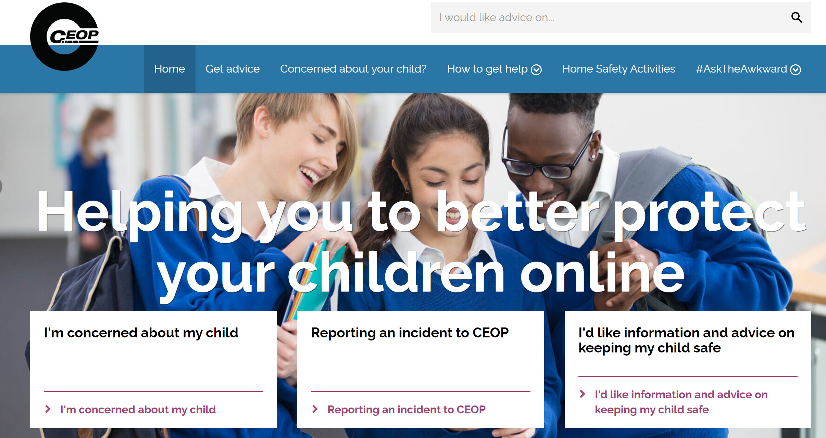  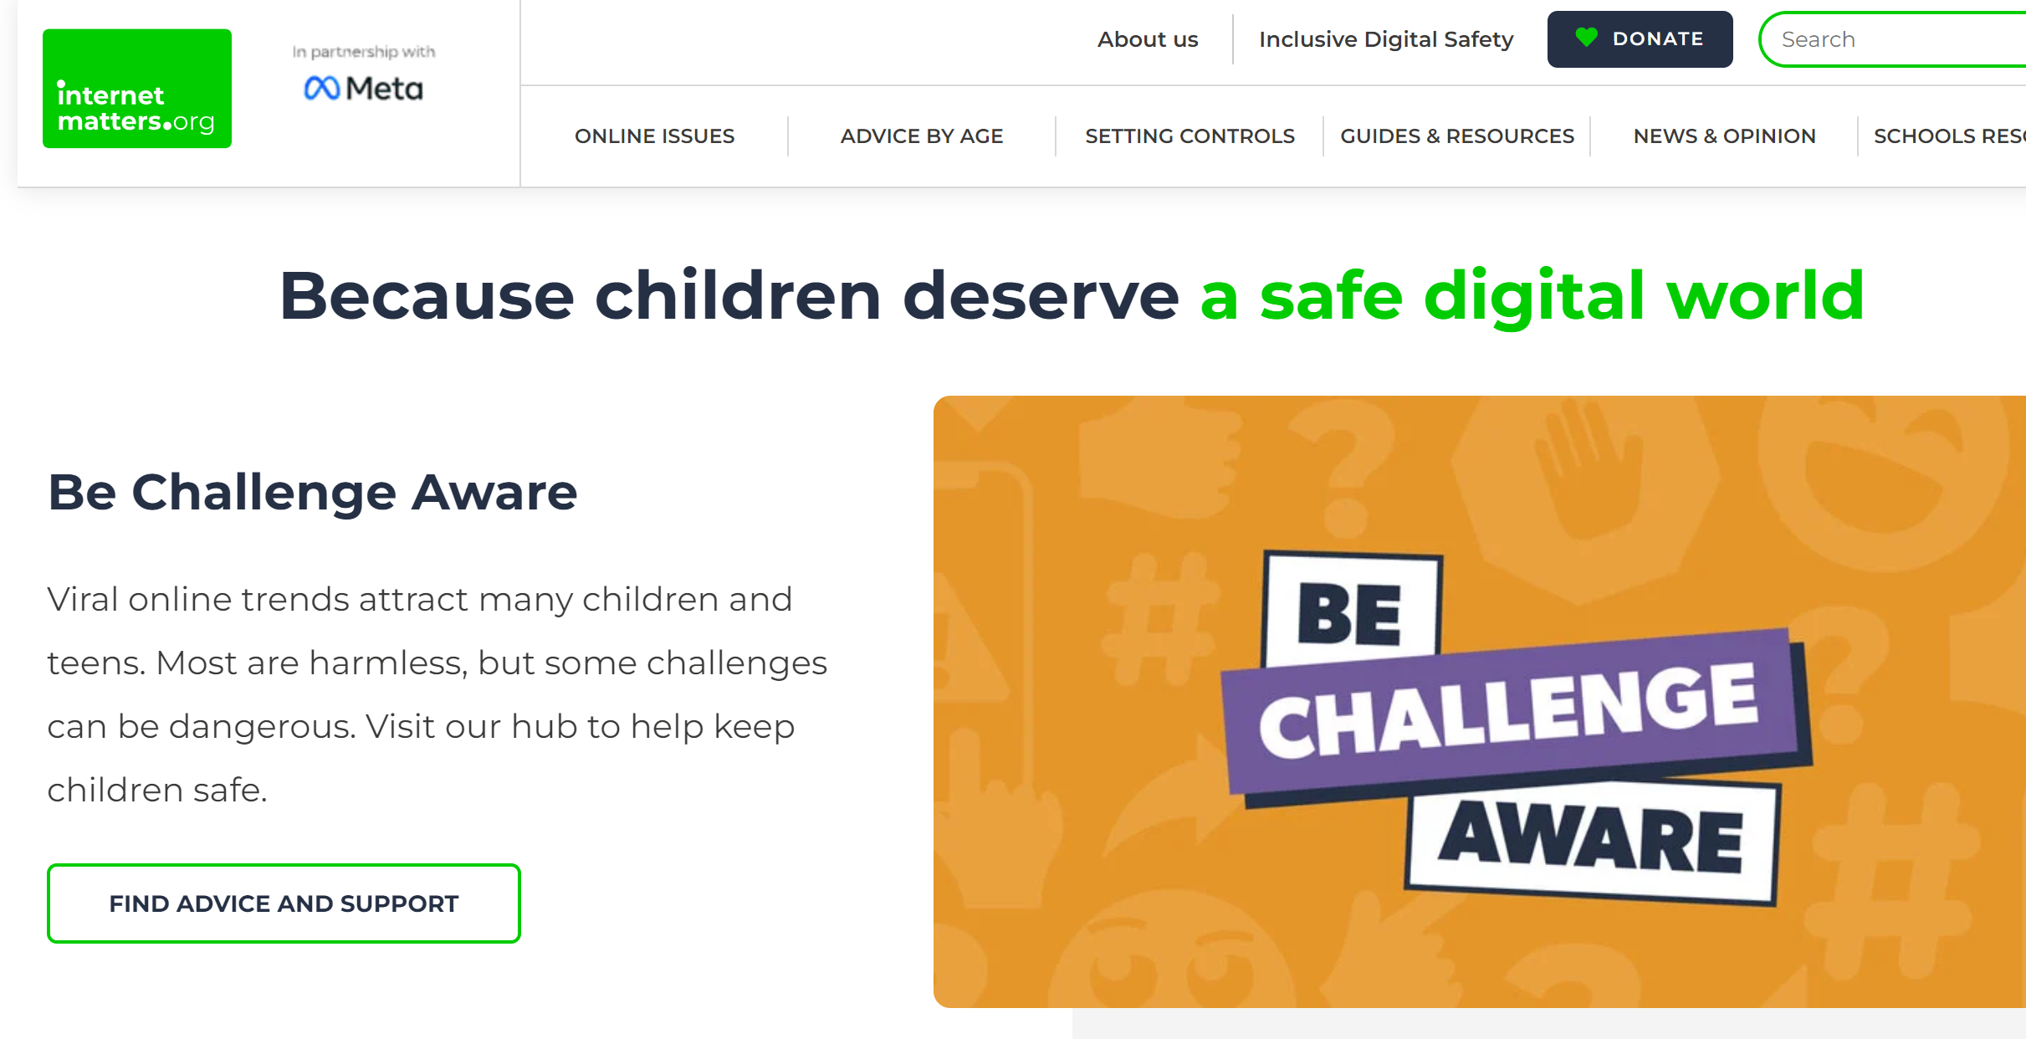 | This is the Child Exploitation and Online  Protection (CEOP) Centre. It’s a one stop shop for most information about online safety. https:www.thinkuknow.co.uk/teachers  (excellent resources) http://educateagainsthate.com/ -  This is the government website to help parents and professionals understand the risks of children  and young people being radicalised by extremists online and how to keep children safe from this.
Mental Health    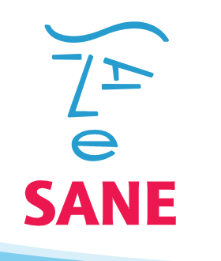 | We have some useful self-help guides/leaflets available for you to access online. The guides are available for you  to read online. The self-help guides can be accessed by  typing the below link into your URL and selecting ‘Self Help  Guides’: www.hacw.nhs.uk/a-to-z/letter-s/  SANE  0845 767 800  Email: sanemail@org.uk  Samaritans  116 123  (24 hour helpline)  Worcester Samaritans  Rethink Mental Illness  0300 5000 927  Mental Health Foundation  www.mentalhealth.org.uk
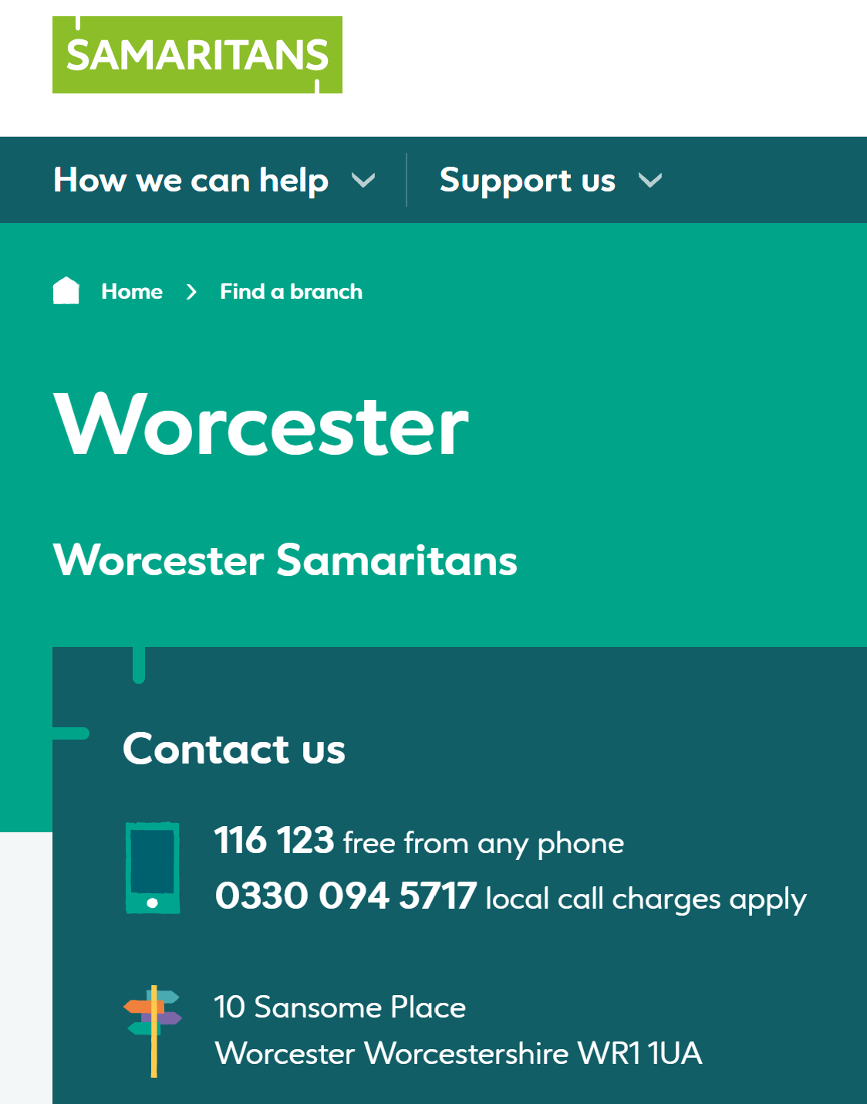

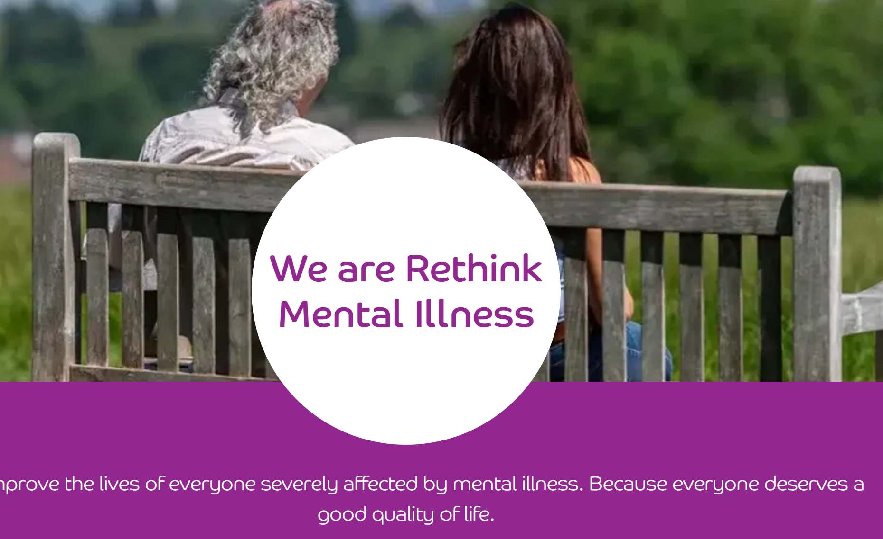



   | MIND  0300 123 3393 or  text 86463 www.mind.org.uk  Anxiety UK  08444 775 774  www.anxietyuk.org.uk
Bullying (including cyberbullying)/ Child death/suicide/prevention    0808 800 2222    0800 1111   | Cyberbullying is using the internet, email, online games or any digital technology to threaten, tease, upset or humiliate someone else.
 | If the police consider a message or post to be potentially criminal, they will take appropriate action. This could involve arresting the person responsible or interviewing them under caution. Cases involving sustained abuse or where someone’s life is threatened will be treated seriously. The police will consider all of the circumstances when considering the best response to a report of cyber bullying. They will assess how vulnerable the victim is and what resources are required to trace the offender via social networking sites that often operate abroad and to different legislation. In certain cases it may be difficult to take action if the offender isn’t in the UK. They will work with the victim to bring about the most suitable and proportionate conclusion, this will include alternative options that include the officer in the case using their discretion and working with the offender to record an apology to the victim.

Hollie Guard-A new personal safety APP   | - Hollie Guard keeps your entire family safe.  - Keep an eye on your children while they’re  traveling to and from school with Journey.  - Teens can get help quickly while out with friends.  - Parents, guardians, and caregivers are automatically contacted by both SMS and email.
Hate Crime     | A hate crime is a criminal offense whose motivation can be shown to be race, national origin, religion or sexual orientation. A difference of race alone is NOT sufficient to make it a hate crime. There would have to be evidence of racial slurs or racial statements in addition to the crime (this does not trivialise other serious offenses that are NOT hate crimes).  Hate Crime:  West Mercia Police:  Email: contactus@westmercia.police.uk Emergency number: 999  Non-Emergency number: 101

Children with disabilities team (CWD)  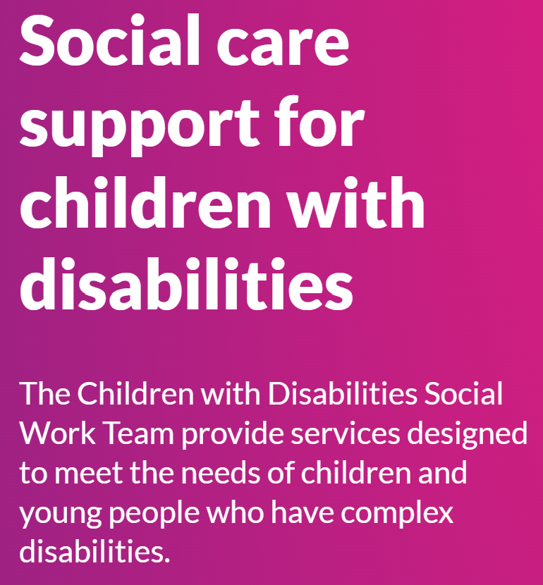 | The Children with Disabilities (CwD) Social Work Team provide services designed to meet the needs of children and young people who have complex disabilities.  The CwD Social Work Team is one of a range of services that can provide support to children and young people with disabilities and their families. Other services available are those provided by health, education, play and youth services as well as community resources provided by voluntary agencies.  The CwD team offer services to those children and  young people requiring additional resources in respect of their disability, where the disability has a profound impact on the child or young person’s life.  An assessment will be offered where the child has a condition which is substantial, long lasting or permanent, is a physical and/or learning disability or a life limiting, life threatening condition. These may include:  - severe learning disabilities  - severe physical disabilities  - severe developmental delay in motor and or cognitive functioning  - profound multiple disabilities  - severe sensory impairment (registered blind and/or profoundly deaf)  - complex and severe health problems that arise from the disability, that are life threatening, degenerative illness or organic disorder resulting in severe disability  - a diagnosis of Autistic Spectrum Condition with an associated learning disability and where the condition severely affects day to day functioning

    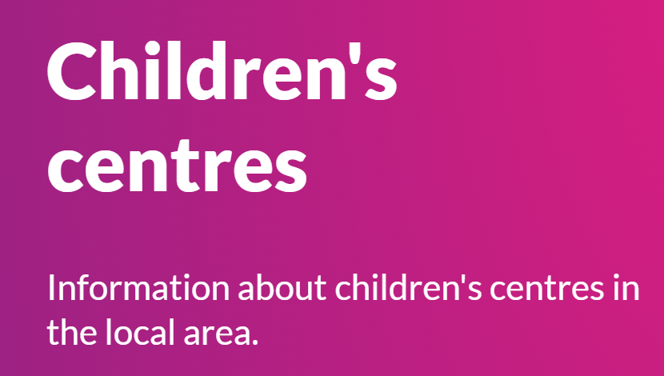    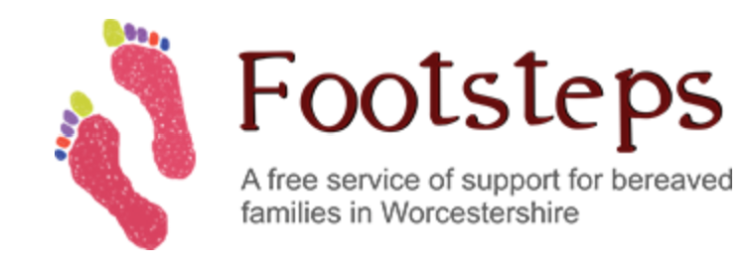    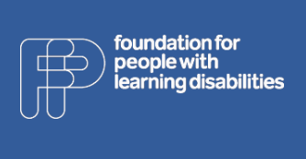 | .SEN Services and Support Groups  - 9 Tea Cups  - Autism in Worcestershire  ASPIE is a social self-help and motivation group for adults with Asperger's Syndrome. We provide a centre in Worcester where Aspies feel welcome and accepted.  - Childrens Centres. your local Children's Centre  Community Paediatric Service is concerned with developmental delay and learning disability; Motor difficulties such as cerebral palsy and muscular dystrophy; Neuro-developmental conditions including ADHD and ASD; complex behavioural difficulties; sensory impairment; statutory medical & educational assessments  - Disability Information Advice Line (DIAL) Worcestershire  Website of the disability advice line South Worcestershire; local info on: Mobility; Benefits and Finance; Carers Support and Respite; Community and Voluntary Support; Disabled Children's Services; Education and Employment; Health; Housing; Independent Living; Learning Disabilities; Legal Support; Leisure and Holidays; Mental Health; Mobility and Aids to Daily Living and Older People's Services  Footsteps is a registered charity providing support for bereaved children, young people and their families in Worcestershire following the death of a parent, sibling or other significant person in their life. We guide and support bereaved children and young people, and help them manage their grief.  H&W Dyslexia Association  Hereford and Worcester Dyslexia Association (HWDA) is a local charity which covers the two counties and aims to help by: providing specialist teaching in literacy, maths and study skills for children with dyslexia or dyslexic-type difficulties and/or dyscalculic-type difficulties through its specialist tuition centres.  We work with people with learning disabilities, their families and the people who support them.

DDNs (Dangerous Drug Networks)    Child Criminal Exploitation (County Lines)   | DDN’s are drug dealing gangs who target vulnerable people in order to set up drugs distribution networks.  These criminals are using extreme violence to establish a presence, displacing an existing drug supply chain and intimidating rivals, witnesses and victims, this has resulted in local murders.  DDN’s exploit vulnerable teenagers to become drug runners for their network. Early intervention and intelligence are key to safeguard and protect the vulnerable.  Criminal Exploitation of children and vulnerable adults: County Lines guidance (publishing.service.gov.uk)  Child exploitation  We provide support for young people, professionals, parents, and carers, with the aim of preventing or stopping child exploitation and missing incidents.

Child Sexual Exploitation (CSE)    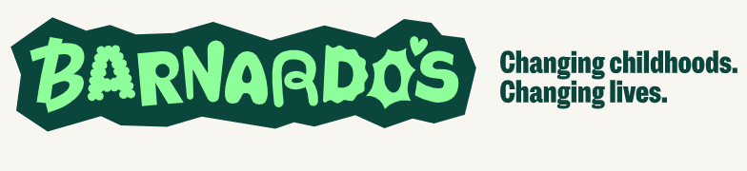         | West Midlands Safeguarding Children Procedures has a page dedicated to Child Sexual Exploitation. It provides information about child sexual exploitation, the roles and responsibilities of relevant agencies and the procedures practitioners should follow to ensure the safety and well-being of children and young people whom it is suspected have been sexually exploited or are at risk of sexual exploitation.  Key facts about CSE  - It affects both girls and boys and can happen in all communities.  - Any young person can be targeted but there are some particularly vulnerable groups: Looked After Children, Children Leaving Care and Children with Disabilities.  - Victims of CSE may also be trafficked (locally, nationally and internationally).  - Over 70% of adults involved in prostitution were sexually exploited as children or teenagers.  - Sexual violence or abuse against children represents a major public health and social welfare problem within UK society, affecting 16% of children under 16. That is approximately 2 million children.  Making a referral  The Local Authority has a duty to make enquiries where a child may be suffering harm or neglect. If you think that a child may be at risk then you can let us know via the referral form linked below  - Barnardo's spot the signs: Advice for parents, professionals and young people on the signs of sexual exploitation and how to keep safe  - Department for Education (Gov.uk) National Action Plan for Tackling Child Sexual Exploitation  - Parents Against Child Sexual Exploitation pace is the leading national charity working with parents and carers whose children are sexually exploited  - NSPCC definitions, statistics, facts and resources about CSE.  - NWG Network: Fighting against CSE and working to inform, educate and prevent child sexual abuse within the UK.
Domestic violence - this includes all kinds of abuse (In line with KCSIE 2021)  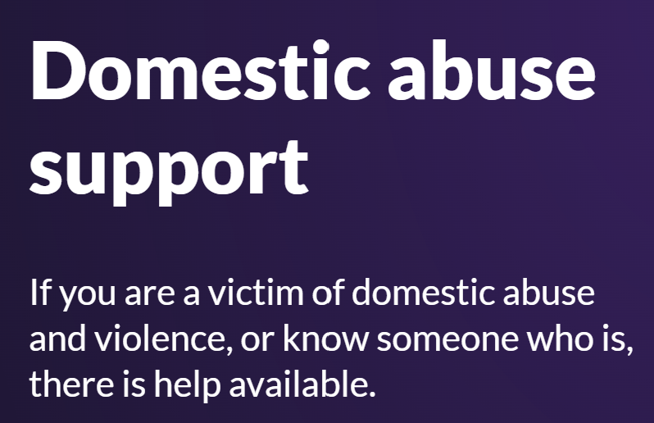  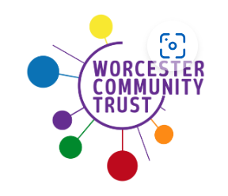 | West Mercia Women's Aid: 0800 980 3331  0800 783 1359  helpline@westmerciawomensaid.org  DAWN – Domestic Abuse Support Worcestershire

Teenage relationship abuse  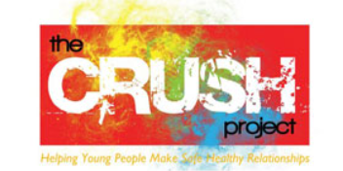 | Crush  CRUSH is an awareness raising and support programme to help young people make safe and healthy relationships. The sessions are run in small groups and are specifically designed for 13-19 year olds.
Fabricated and induced illness (FII)   | Fabricated or induced illness (FII) is a rare form of child abuse. It occurs when a parent or carer , exaggerates or deliberately causes symptoms of illness in the child.

Faith abuse | Faith and belief-based child abuse, including  practices around ‘spirit possession’ and  ‘witchcraft’, is a hidden crime, which makes it  difficult to quantify in terms of magnitude. However, from our own experience and in consultation with communities, we know this kind of abuse is under-reported.  Further contacts for advice can be found from the local representatives for some faiths.
Honour based violence (HBV)   | Honour’ based violence (HBV) occurs when perpetrators believe a relative or other individual has shamed or damaged a family’s or community’s ‘honour’ or reputation (known in some communities as izzat), and that the only way to redeem the damaged ‘honour’ is to punish and/or kill the individual. ‘Honour’ based violence is a term that is widely used to describe this sort of abuse however it is often referred to as so called ‘honour’ based violence because the concept of ‘honour’ is used by perpetrators to make excuses for their abuse. There is a very strong link between ‘honour’ based violence, forced marriage and domestic abuse. The term ‘Honour Based Violence’ is the internationally recognised term describing cultural justifications for violence and abuse. Honour Based Violence cuts across all cultures and communities: Turkish, Kurdish, Afghani, South Asian, African, Middle Eastern, South and Eastern European for example. This is not an exhaustive list. Where a culture is heavily male dominated, HBV may exist. The police have made it a high priority to help communities fight back to tackle both honour based violence and hate crime.  The ‘Honour Network Help line’: 0800 599 9247

Female genital mutilation (FGM)   | Female Genital Mutilation (FGM) comprises all procedures involving partial or total removal or the external female genitalia. FGM is illegal in the UK and as of October 2015 mandatory reporting commenced. If education staff or other professionals discovers that an act FGM appears to have been carried out on a girl under 18 years old there is a statutory (legal) duty on teachers for them PERSONALLY to report it to the police.  Any suspicion of FGM should be referred to the Police and social care.
Forced marriage     | UK Forced Marriage Unit fmu@fco.gov.uk Telephone: 020 7008 0151  Call 999 (police) in an emergency. www.gov.uk/stop-forced-marriage for information on Forced Marriage. Visit Home Office website to undertake Forced Marriage e-learning package  Prevention Freedom Charity- Aneeta Prem ‘But it’s not fair’ book. A book for teenagers looking at forced marriage from the point of view of school friends of the girl who went to India and didn't come back. This book promotes discussion. www.freedomcharity.org.uk The Freedom Charity (UK charity) have a helpline, text facility and app which can be downloaded to help to provide support and protection for victims of abuse, FGM or forced marriage. They can be contacted on tel: 0845 607 0133 or text 4freedom to 88802 or go to the website to download the app from the app  page.
Gangs and youth violence   | This is a website for the Youth Violence prevention initiative
Gender-based violence/violence against women and girls    Hope House SARC (Sexual Assault Referral Centre):  01452 754390   | For information about West Mercia Rape and Sexual Abuse visit: https://www.wmrsasc.org.uk/  FGM (Female Genital Mutilation) is violence against women and girls. Forced marriage and so called ‘Honour’ based violence are a violation against human rights and is a high priority area of the national and local Violence Against Women and Girls Agenda. It is, primarily an issue for young women and girls aged between 13 and 30 years.  www.onyourmindglos.nhs.uk for ‘I’ve been raped  or sexually assaulted’ information.

Gender Identity Issues    0845 231 0505  Address: 76, The Ridgeway, Astwood Bank, B96 6LX | The Gender Trust is a listening ear, a caring support and an information centre for anyone with any question concerning their gender identity, or whose loved one is struggling with gender identity issues. People who might be Transgender, Transsexual or people who do not identify with the gender they were assigned at birth or those who are simply unsure.
Private fostering   | National Fostering Agency (NFA) Call on: 0808 284 9226  Kinship Care  Kinship care means that relatives or friends look after children who cannot live with their parents. Visit this website for more information: http://www.worcestershire.gov.uk/privatefostering
Preventing Radicalisation and Extremism/HATE (PREVENT duty)    Anti-Terrorist Hotline: tel 0800 789 321  Email to the Home office: counter.extremism@education.gsi.gov.uk.   | www.educateagainsthate.com is the government website providing information and practical advice for parents, teachers  and schools leaders on protecting children from radicalisation and extremism.  While it remains very rare for school age children to become involved in extremist activity to the point of committing criminal acts, young people can be exposed to extremist influences or prejudiced views, including via the internet, from an early age. As with other forms of criminality or risk of harm, early intervention is always preferable. Schools, working with other local partners, families and communities, can help support pupils who may be vulnerable as part of wider safeguarding responsibilities.
Sexting/Sextortion/youth produced imagery   | Sexting is when people share a sexual message and/or a naked or semi-naked image, video or text message with another person. Children and young people may also talk about sharing 'nudes', 'pics' or 'dick pics'.  Children and young people may consent to sending a nude image of themselves. They can also be forced, tricked or coerced into sharing images by other young people or adults online.

Children Missing in Education (CME)    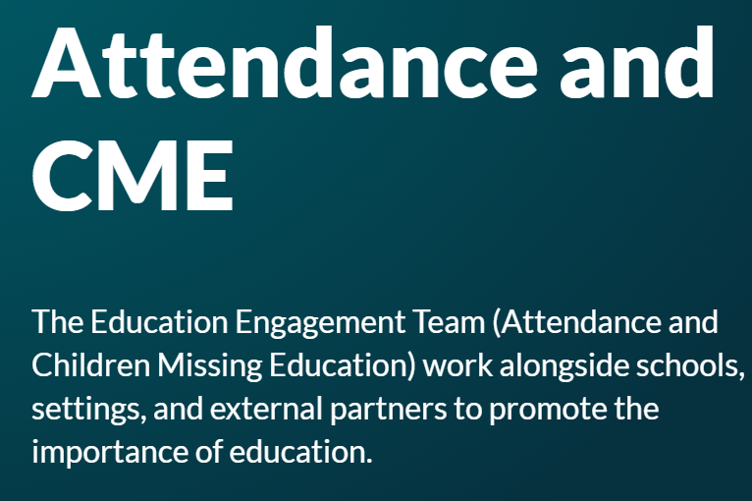 | Children Missing Education (CME) refers to 'any child of compulsory school age who is not registered at any formally approved education activity eg school, alternative provision, elective home education, and has been out of education provision for at least 4 weeks'. CME also includes those children who are missing (family whereabouts unknown), and are usually children who are registered on a school roll / alternative provision. This might be a child who  is not at their last known address and either has not taken up an allocated school place as expected, or has 10 or more days of continuous absence from school without explanation, or left school suddenly and the destination is unknown.
Missing Children and Adults Strategy  (vulnerable children and adults who go missing)   | Every year an estimated 200,000 people go missing in the UK. In some cases, missing adults may have made a choice to leave and ‘start their lives over again’, but the vast majority of missing people, children and adults, are vulnerable and need protection and support. The strategy has three key objectives which provide the right foundations for any effective local strategy to tackle this issue:  Prevention - reducing the number of people who go missing, including through prevention strategies, education work and early intervention in cases where children and adults repeatedly go missing  Protection - reducing the harm to those who go missing, including through a tailored, risk-based response and ensuring agencies work together to find and close cases as quickly as possible at a local and national level  Provision - providing support and advice to missing persons and families by referring then to agencies promptly and ensuring they understand how and where to access help.  The police should be informed if any child or adult goes missing. The Missing Children and Adults strategy can then be referred to for further information and help. It is a home office publication (2011).

Children with family members in prison  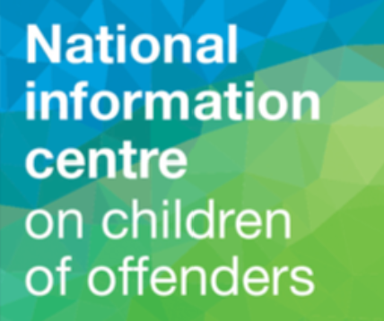 | Approximately 200,000 children have a parent sent to prison each year. These children are at risk of poor outcomes including poverty, stigma, isolation and poor mental health. NICCO provides information to support professionals working with offenders and their children to help mitigate the negative consequences for these children.
Children and the court system | Children are sometimes required to give evidence in courts, either for crimes committed against them or for crimes they have witnessed. There are two guides to support these children which can be found at www.gov.uk (young witness booklet for 5 to 11 year olds) which is a pdf. There is also a document called “going to court and being a  witness age 12 to 17” which is also found at www.gov.uk. Making family arrangements via court can be stressful and entrench conflict in families. The ministry of Justice has just launched an online dispute resolution service. This can be useful to parents and carers. Got to www.gov.uk  and search for “get help with arrangements.”
Stalking    Phone: 0808 802 0300  Email: advice@stalkinghelpline.org    Email: info@paladinservice.co.uk  Phone: 0203 866 4107 | General Advice:  - If it doesn’t feel right it probably isn't!  - Seek support from trusted family/friends  - Report to the police and do this early Keep a diary in a secure location  - Screenshot emails etc and save them  - Photograph/video your stalker if safely possible.  - Get advice: Hollie Gazzard Trust, Paladin  etc…  - Tighten security; home, work and on-line  National Stalking Helpline  For advice and support. The helpline will operate a triage service for local support and make referrals.  Paladin: National Stalking Advocacy Service  For advice and referral.  Hollie Gazzard Trust  - https://holliegazzard.org/
Sexual violence and sexual harassment between children in schools and colleges  0808 500 2222 | Here is advice from the WCC webpage:  West Mercia Rape and Sexual Abuse Support Centre

Early Help Family Support Service:
The Early Help Family Support Service is delivered by Worcestershire Children First directly to families permanently living in Worcestershire who have children aged 0-18 years old and need help and support specifically from a Family Support Worker. For more information, please visit: Worcestershire Children First Early Help Family Support Service | Worcestershire County Council

Health (including mental health, emotional wellbeing, and sexual health)
The Starting Well Partnership offers a range of health services which support both children and families experiencing a range of health issues.

Worcestershire Health Visiting Service | Starting Well (startingwellworcs.nhs.uk)
If your child is under 5 years old and you need advice on issues such as feeding, behaviour, or toileting you can contact the Telephone Advisory Service on 0300 123 9551 (Monday – Friday 9am til 3pm). A Health Visitor will assist you over the phone with any worries, concerns, or questions you have.

School Health Nursing | Starting Well (startingwellworcs.nhs.uk)
School health nurses offer a range of services such as home visits, health needs assessments, time4u drop-in service, school aged hearing and national child measurement programme to support the needs of children and their families.

Text service supporting young people | Starting Well (startingwellworcs.nhs.uk)
Chat health is a free and confidential text service for young people in need of advice or support
To confidentially contact your school nurse, text: 07507331750
Social Prescribing: Onside Advocacy, Worcestershire (onside-advocacy.org.uk)
Social Prescribers support you to take control of your health and look after yourself by making connections with the different types of community support available.

CAMHS | Herefordshire and Worcestershire Health and Care NHS Trust (hacw.nhs.uk)
CAMHS provides mental health help to children, young people and their families across Herefordshire and Worcestershire

Home - Kooth
Kooth is an online mental wellbeing community which offers free, safe, and anonymous support.
Reach 4 Wellbeing | Herefordshire and Worcestershire Health and Care NHS Trust (hacw.nhs.uk)
The Reach4Wellbeing team promotes positive wellbeing to reduce the stigma of mental health by providing short-term group programmes for children and young people age 5-18 experiencing mild to moderate anxiety and low mood.
Papyrus UK Suicide Prevention | Prevention of Young Suicide (papyrus-uk.org)
Papyrus can offer suicide prevent support providing free and confidential helplines, advice, webchats, and resources.

Home | Healthy Minds (whct.nhs.uk)
Healthy Minds’ 24/7 mental health helpline provides support or advice if you, or someone you know, is experiencing a mental health crisis and needs urgent help. Its available 24 hours a day to anyone in Herefordshire and Worcestershire.

Winston's Wish - giving hope to grieving children (winstonswish.org)
Winston’s Wish provide support for children and young people following the death of a sibling, parent, or a person important to a child.

Sexual Health Know Your Stuff | Sexual health | Worcestershire County Council
Worcestershire Integrated Sexual Health Service (WISH) | Herefordshire and Worcestershire Health and Care NHS Trust (hacw.nhs.uk)
WISH offer friendly and non-judgemental specialist services to support with information and advice, contraception, pregnancy, STIs and screening.

Under 21 Saturday Service - Clinic telephone lines are open between 10:00am – 12:30pm on Saturdays - Please call: 01905 681673 for further details.
Young People have a telephone consultation and are asked questions about their relationships. Callers will be advised what to do next and directed towards a clinic if necessary.
WISH have a dedicated Outreach nursing service. Referral forms can be found at www.knowyourstuff.nhs.uk. The Outreach team see young and vulnerable people who couldn’t otherwise access sexual health services.

Free STI test kits and contraception: SH:24 Free Home STI STD Test | Sexual & Reproductive Health (sh24.org.uk)

Bullying (including Cyberbullying)
If you are concerned your child or a child, you know is being bullied there are several services and useful links which can help you support your child as a parent.

In the first instance if bullying is happening at school, please speak to a member of staff who will be able to help.

The following links will provide you with more information if you or someone you know is being bullied:
Is your child or someone you know being bullied? | Worcestershire County Council
Are you being bullied? | Worcestershire County Council
Cyberbullying | Worcestershire County Council
Kidscape | Resources and Publications

Online Safety
If you have concerns around the safety of your child or a child you know online, the following links will provide you with information, support, and advice to help understand the risks and keep your child safe online:
- Think U Know | Information for parents
- Online safety | Barnardo's (barnardos.org.uk)
- Educate Against Hate
- www.internetmatters.org
- BBC | 8 tips for staying safe online

Sexting is the sending or receiving of sexually explicit images, videos or conversations online.
Sexting and sending nudes | NSPCC
Think U Know | Parents Sexting Guide

Relationships
The following services and links offer information, advice, and intervention on healthy relationships for your family and children:
- Healthy relationships | NSPCC

- Challenges at home: Harmony at Home – information and support for parent carers | Worcestershire County Council

- CRUSH is an awareness raising and support programme to help young people make safe and healthy relationships. http://www.westmerciawomensaid.org/crush/

- Relationships | The Family Hub | Worcestershire County Council

Friendships and relationship in teenagers
Making friends and starting new relationships are a big part of getting older. It's very common to fall out with friends or break up from relationships – which can be very difficult to deal with. You might also be in a relationship that doesn't feel right and need some advice about what to do. The websites below contain lots of information about making friends, peer pressure, healthy and unhealthy relationships, sex and much more. There is also information available for parents around how to talk to your child about friendships, sex and relationships.
Childline - Friends, relationships and sex (opens in a new window)
Disrespect Nobody - Signs to spot (opens in a new window)
NHS Choices - How to talk to your child about sex (opens in a new window)
NHS Choices - Sex and young people (opens in a new window)

SEND (Special Educational Needs and/or Disabilities)

Please include any information / support you offer in your setting.

If you are looking for information or advice the following links will help you:
SEND Local Offer | Worcestershire County Council or contact localoffer@worcschildrenfirst.org.uk

SEND Information, Advice, Support Service SENDIASS Worcestershire and Herefordshire (hwsendiass.co.uk)

Social care support for children with disabilities | Worcestershire County Council

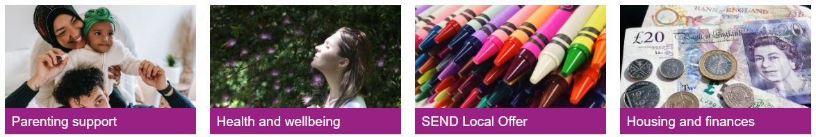

The Online Family Hub has been developed to provide you with a range of different types of resources that are available to you online, on the phone or face to face that you can access directly.

The Family Hub can offer you support and information with the challenge’s family life can bring.

The Family Hub | Worcestershire County Council
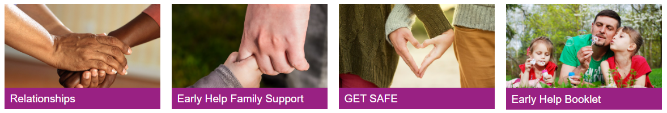

Early Help in Worcestershire have created a booklet to help families find out about the help and support available in the county for children and young people aged 0-18 years old. The new booklet will help you and families find the most appropriate support.
To download this booklet, please visit: The Family Hub | Worcestershire County Council

Worcestershire Young Carers
Worcestershire Young Carers aim to identify, and support children and young people aged 7 to 24 years who have a caring role within the home and help look after a parent, sibling, or grandparent due to illness, disability, physical or mental health difficulties or substance misuse.
Worcestershire Young Carers/Shropshire Young Carers | YSS

Carers | Worcestershire County Council

Finance, Housing and Employment
If you are facing challenges around employment and income, please contact the local job centre who can with offer support with jobseekers’ allowance, incapacity benefit, employment and support allowance and income support:

[Local] Job Centre Plus,

Worcester Job Centre Plus, Haswell House, Sansome Street, Worcester, WR1 1UZ
Telephone: 0845 6043719
Citizen’s Advice Bureau Worcester Citizens Advice Bureau and WHABAC (Worcester Housing and Benefits Advice Centre) (citizensadviceworcester.org.uk)
Building Better Opportunities is a service to help local people move closer to employment. Building Better Opportunities (fusionworcs.co.uk)
For information on what financial and housing support is available in Worcestershire, please visit:
Housing and finances | The Family Hub | Worcestershire County Council

Parenting Support
The Starting Well Partnership offer a range of parenting support, information, groups, and courses. For information on the groups available please visit: Parenting groups | Starting Well (startingwellworcs.nhs.uk)

Parenting Talk is an online hub offering information, advice, and a free confidential online chat with a parenting advisor.
Parent Talk - Support for Parents from Action For Children

Homestart can work with you to provide one to one support in the family home each week. This service provides support tailored to your needs and can help you as parents they learn to cope and build confidence to provide as best you can for your children.
Home-Start | South Worcestershire (home-startsw.org.uk)

Family Information Service
Do you need advice and support around finding childcare? The following link will provide you with the contact details of the Family Information Service’s District Teams: Family Information Service | Worcestershire County Council

Substance Misuse
Swanswell - Cranstoun
Here 4 Youth is support service for children and young people up to the age of 18 who may be struggling with their use of drug and / or alcohol. Here4YOUth Worcestershire - Cranstoun

Do you have a family member in prison?
Do you have a family member in prison which is having an impact on your child? Support is available to work with both the person in prison and your family.
NICCO

Families First provides support and guidance in a safe space, to enable the whole family to cope with the demands of having a partner, and parent, in prison: Families First | YSS

Get Safe
If you are worried your child is at risk of being tricked, forced, or made to work in the criminal world please speak to a member of staff and visit Get Safe for help and information.

If you are experiencing any of these challenges or issues affecting family life, please contact a member of staff who will be happy to provide you further advice and support.

